|  |
| --- |
| Functional Specification Document  Electronic Census System (ECS) |

**DOCUMENT VERSION 1.2**

**23-11-2023**

**AUTHORS**

|  |  |  |
| --- | --- | --- |
| **Name** | **Role** | **Email** |
| Pablo Maya Villegas | Project Manager | [pmayav@eafit.edu.co](mailto:pmayav@eafit.edu.co) |
| Juan Esteban Avendaño Castaño | DevOps Engineer | [jeavendanc@eafit.edu.co](mailto:jeavendanc@eafit.edu.co) |
| Hobarlan Uparela Arroyo | Software Architect | [huparelaa@eafit.edu.co](mailto:huparelaa@eafit.edu.co) |
| Maria Paulina López Salazar | UX/UI Designer | [mplopezs@eafit.edu.co](mailto:mplopezs@eafit.edu.co) |
| Mateo Muñoz Cadavid | Data Engineer | [mmunozc4@eafit.edu.co](mailto:mmunozc4@eafit.edu.co) |
| José Manuel Camargo Hoyos | Data Engineer | [jmcamargoh@eafit.edu.co](mailto:jmcamargoh@eafit.edu.co) |

**DOCUMENT HISTORY**

|  |  |  |
| --- | --- | --- |
| **Date** | **Version** | **Document Revision Description** |
| 28 August 2023 | 1.0 | Initial draft and context of the solution. |
| 6 September 2023 | 1.1 | Development and architectural decisions. |
| 23 November 2023 | 1.2 | Logical diagrams and refinements. |

**APPROVALS**

|  |  |  |  |
| --- | --- | --- | --- |
| **Approval Date** | **Approved Version** | **Approver Role** | **Approver** |
|  |  |  |  |
|  |  |  |  |
|  |  |  |  |
|  |  |  |  |

## Table of Contents

Table of Contents 3

1. Introduction 3

1.1 Purpose of the document 4

1.2 Project Scope 4

1.3 Related documents 4

1.5 Terms/Acronyms and Definitions 5

1.6 Risks and Assumptions 7

2. System/ Solution Overview 8

2.1 Context Diagram 9

2.2 System Actors 15

2.3 Logical diagrams 16

3. Functional Specifications 18

4. Other System Requirements/ Non-Functional Requirements 29

References 31

# Introduction

This document aims to address the DoS's need by proposing the implementation of an ECS. As part of the efforts of the Republic of Bolumbia to enhance data collection methodologies, the ECS project aims to revolutionize how population data is gathered and analyzed.

The history of the DoS in conducting the Population and Housing Census is a significant statistical effort that provides crucial insights into the country's demographic and housing trends. Traditionally, this process involves distributing and collecting census forms on paper. However, with the rapid proliferation of digital technology and the increasing accessibility to the internet, the DoS envisions an innovative approach to data collection through the introduction of the ECS.

## Purpose of the document

The Functional Specification Document is a document that provides detailed information on *how* the system solution will function and the requested behavior. This document is created based on the high-level requirements identified in the Business Requirements Document and provides traceability on the functional specifications back to the business requirements. Included in this document will be the detailed functional requirements including use cases, system inputs and outputs, process flows, diagrams, and mockups.

## Project Scope

With the ECS, the population of Bolumbia will be able to complete their census forms electronically over the internet using desktop computers or mobile devices. This will eliminate the need for paper forms, improving accessibility and efficiency of data collection.

The ECS infrastructure will be scalable and flexible environment. Rigorous testing will be followed to ensure its reliability and functionality. Once successfully tested, the application will be deployed in a production environment.

Integration with the existing systems represents another vital aspect of the project. This integration fosters seamless data exchange and collaboration across different departments and systems with the DoS, facilitating efficient information flow and cooperation. There will also be crucial continuous support, featuring a robust system for assistance and troubleshooting, covering both the ECS application and the infrastructure.

## Related documents

|  |  |  |
| --- | --- | --- |
| **Component** | **Name (with link to the document)** | **Description** |
| Case study | [Case Study Background_EAFIT.docx](https://eafit.sharepoint.com/:w:/s/Section_ST0261_2885_2366/ET3Ohhk7RKxOtNEt3fPL7ZEBsn8Dz6ICNf8Ad_hZyGaQvQ?e=sQCaBi) | This document provides a comprehensive description of the Case Study under analysis and resolution. |
| Architectural decisions | [Architectural_Decisions.docx](https://1drv.ms/w/s!AmWYZcVQuKl4ofkEIRif3L3EzPKiJg?e=nOMClF) | This document explains in detail all the decisions taken for the architecture of the whole system. |
| Functional Specification Document | [FunctionalSpecificationDocument.docx](https://eafit-my.sharepoint.com/:w:/g/personal/pmayav_eafit_edu_co/ETbNbnG0ivlJvBSzLWcT0dwB7fOKHtGj6qJnXHJImjKOjw?e=bdUYjt) | This very document displays the problem, solution, diagrams and most of the contents about the project. |
| Repository | [Github.git](https://github.com/mmunozc/census-collector.git) | This repository has all the programs proposed by us. |

## 1.5 Terms/Acronyms and Definitions

|  |  |  |
| --- | --- | --- |
| **Term/Acronym** | **Definition** | **Description** |
| Bolumbia Post | The mail and parcel delivery service in Bolumbia. | The service responsible for delivering mail and parcels within the region of Bolumbia. |
| Census | The Census of Population and Housing provides a snapshot of Bolumbia's people and their housing. | The statistical collection that captures information about the population and housing in Bolumbia, serving as a crucial source of demographic data. |
| Census Night | Specific night, usually the first Tuesday of August three years from now, when a census is conducted and information about the population and housing is collected. | During the month of August, known as the enumeration period, every dwelling must complete a Census return. Although responses can be submitted throughout this period, the questions should reflect the dwelling's situation on Census Night. It is expected to have a greater workload impact on this day, so the servers should scale accordingly. |
| CFN | The CFN is a unique number assigned to each dwelling by the Census Collector upon delivery of the paper Census Form. | Where:   * CWL: Is the Collector Workload (CWL) (approximately 27,000 CWLs) followed by its alpha Check Digit (CD) * RNO: Is a sequential number issued by the collector when delivering forms called the RNO (Record Number) followed by its alpha Check Digit (CD).   The CFN and ECN are used by the respondent as credentials to log on to ECS. |
| CWL | The seven-digit Collector Workload (CWL) component of the CFN code | A numerical identifier representing the workload of a Census Collector, used in the CFN code. |
| RNO | RNO (Record Number) is a four-digit sequential number part of the CFN which is issued by the collector when delivering forms. | A sequential number within the CFN, assigned by the Census Collector during form delivery. |
| ECN | The ECN uniquely identifies a Census form | Where:   * There is a first 8-digit random sequence followed by 4 check digits. * The ECN and CFN are used by the respondent as credentials to log on to ECS. |
| DoS | Bolumbia’s Department of Statistics | The governmental department responsible for statistical data collection and analysis in Bolumbia. |
| Dwelling | A dwelling is an important legal concept which defines a self-contained unit of accommodation used by one or more households as a home... | A legal term defining a self-contained living unit, such as a house or apartment, used by individuals or households as their place of residence. |
| ECS | The Electronic Census System (ECS) is the technology platform under development to facilitate the submission of census forms by the residents of Bolumbia | The Electronic Census System (ECS) is a designed platform to empower individuals who choose to submit their census forms online, facilitating a streamlined census process. It allows users to provide their information independently and efficiently, contributing to an expedited data collection process. |
| Enumeration period | Period during which Census response must be submitted. | The timeframe designated for submitting responses to the census. |
| PD | Private Dwelling (refer to Dwelling) | Abbreviation for "Private Dwelling," referencing the concept of dwelling as defined earlier. |

## Risks and Assumptions

**Risks:**

* **Data Transfer and Integration:** Challenges related to the accurate and secure transfer of data from ECS to the DoS Electronic Census Processing system and subsequent integration into the DoS Census database.
* **Technical Glitches During Enumeration:** The risk of technical glitches or downtime during the census enumeration period, especially on Census Night, which could disrupt the online submission process.
* **User Acceptance Testing:** The possibility of discovering defects or issues during the DoS User Acceptance Testing that could affect the functionality of the ECS.
* **User Instructions:** The clarity of instructions provided to households for using the Electronic Census Number and Census Form Number to complete their census response online via ECS.
* **Data Security and Privacy:** Potential risks of data breaches or unauthorized access when transferring sensitive respondent information from ECS to the DoS systems.

**Assumptions:**

* **User Readiness:** Assuming that households will understand and follow the provided instructions to utilize their Electronic Census Number and Census Form Number for online responses via ECS.
* **User Familiarity:** Assuming users are familiar with basic digital processes, enabling them to navigate the online platform.
* **Data Transfer Reliability:** Assuming that data transfers between ECS and the DoS systems occur reliably and accurately without significant technical issues.
* **Help Desk Support:** Assuming that the Census help desk provided by the DoS, with input from our organization's development group, effectively assists respondents with queries related to ECS.
* **Daily Communication:** Assuming that daily reports and information exchange between our organization and the DoS proceed smoothly, contributing to the successful operation of ECS.
* **Addresses database:** Assuming that the DoS gives us access to the database of all the addresses with their assigned CFN and ECN.

**Restrictions:**

* Respondents can complete the census using a web browser on either a computer or a mobile device, without requiring any additional software.
* The system must adhere to the Electronic Transactions Act 2009 enforced by the DoS.
* The system's foundation should rely on a cloud-based development environment for its infrastructure.
* All the forms data should be in the DoS processing system by the end of census night.
* The sistem should not have all available capacity used from day one, it must be cost effective.

# System/ Solution Overview

The proposal is for the Republic of Bolumbia’s Department of Statistics. The Department of Statistics (DoS) wants to implement a new Electronic Census System (ECS) for the next population Census to complement the existing manual process for collecting information about the current population.

Its objective is to accurately measure the number and key characteristics of people who are in Bolumbia on Census Night, and of the dwellings in which they live. This information provides a reliable basis for estimating the population of each of the provinces and local government areas, primarily for electoral purposes and for planning the distribution of government funds. Census data are also used by individuals and organizations in the public and private sectors to make informed decisions on policy and planning issues that impact on the lives of all Bolumbians. Everyone in Bolumbia is legally required to complete a Census form, to ensure that the Census data give an accurate and complete picture of the nation.

We are dedicated to delivering four distinct software components for an efficient and streamlined digital census process. These components include:

* Census Web Portal: A user-friendly website where citizens can seamlessly complete their digital census forms. The portal provides an intuitive interface for easy data entry and submission.
* Real-time Analytics Program (DoS Analytics): This program offers dynamic, real-time data visualization and analysis. It not only displays information promptly but also stores it for future reference and in-depth analysis. This analytical tool contributes to a comprehensive understanding of census trends and patterns.
* Census Collector App: Specifically designed for field workers, this mobile application provides a clear and organized display of assigned dwellings. Field agents can efficiently track and manage the current status of each dwelling, marking them as completed upon physically collecting paper forms. The app streamlines the data collection process and enhances the overall efficiency of census workers.
* Central API: Serving as the backbone of our census system, the Central API plays a pivotal role in monitoring access and facilitating seamless communication between different components. It responds to requests from the web portal, analytics program, and collector app, enabling them to read or write data to the centralized database. This centralization ensures data integrity and consistency across all aspects of the census software suite.

With these four interconnected components, our goal is to create a robust and integrated digital census solution, providing citizens, field workers, and administrators with the tools they need for a successful and data-driven census process.

To ensure robust performance capable of handling a large volume of concurrent requests, we propose a Kubernetes-based elastic and scalable solution for both the Census Web Portal and the Central API. This strategic approach is designed to efficiently manage thousands of requests, providing a seamless and responsive user experience. By leveraging Kubernetes, we can dynamically scale resources in response to demand, optimizing the allocation of computing power as needed. This elasticity ensures that the web portal and API can gracefully handle peak loads during the high-traffic periods of census night, guaranteeing reliable and efficient service delivery.

Additionally, Kubernetes facilitates automated container orchestration, streamlining deployment processes and enhancing system reliability. This not only improves the overall resilience of the census infrastructure but also enables quick adaptation to changing workloads. The scalability and flexibility offered by the Kubernetes-based solution contribute to the system's ability to respond to the dynamic demands of a large-scale census operation on census night. Our approach aims to provide a high-performance, resilient, and easily scalable foundation for the Census Web Portal and Central API, ensuring a smooth and reliable experience for users and administrators alike.

## 2.1 Context Diagram

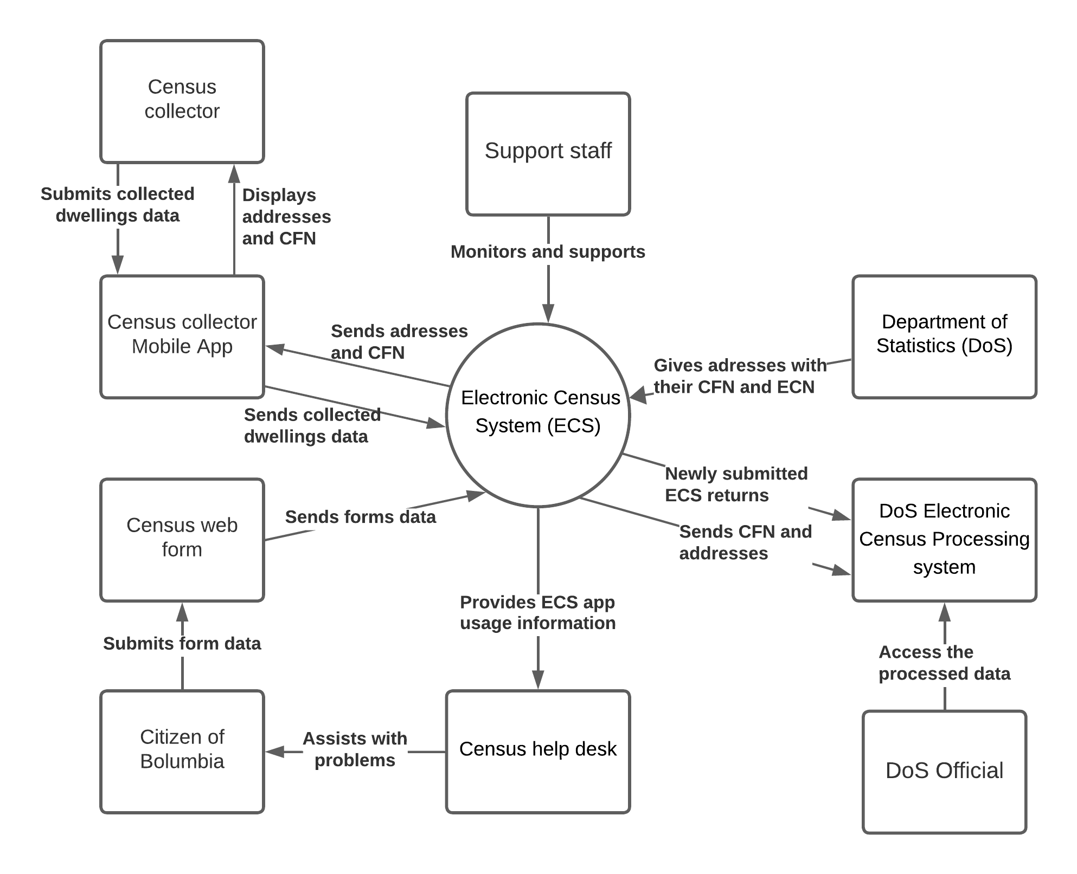

[*https://lucid.app/lucidchart/f8e25859-a8ea-4255-80ba-35818ea6f82b/edit?viewport_loc=-117%2C175%2C2451%2C1218%2C0_0&invitationId=inv_0af5528b-5b48-429e-a9f4-1a523fa68230*](https://lucid.app/lucidchart/f8e25859-a8ea-4255-80ba-35818ea6f82b/edit?viewport_loc=-117%2C175%2C2451%2C1218%2C0_0&invitationId=inv_0af5528b-5b48-429e-a9f4-1a523fa68230)

### 2.1.1 Class Diagram

### 

[*https://drive.google.com/file/d/1tw-WYOtBhKgj4oBnfKBsyTuTMiZP2Pyi/view?usp=sharing*](https://drive.google.com/file/d/1tw-WYOtBhKgj4oBnfKBsyTuTMiZP2Pyi/view?usp=sharing)

**2.1.2 Architectural Overview**

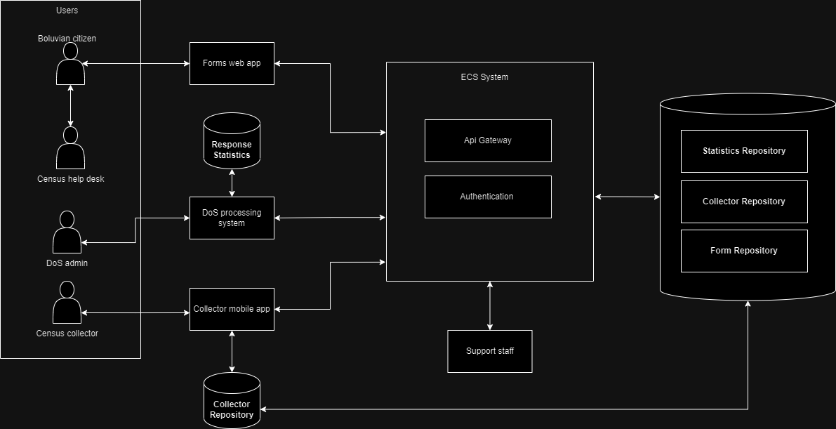

[***https://drive.google.com/file/d/19QOjG961Xo95DpXi_ZhVWVa4asIHxXOQ/view?usp=sharing***](https://drive.google.com/file/d/19QOjG961Xo95DpXi_ZhVWVa4asIHxXOQ/view?usp=sharing)

**2.1.3 Component diagram**

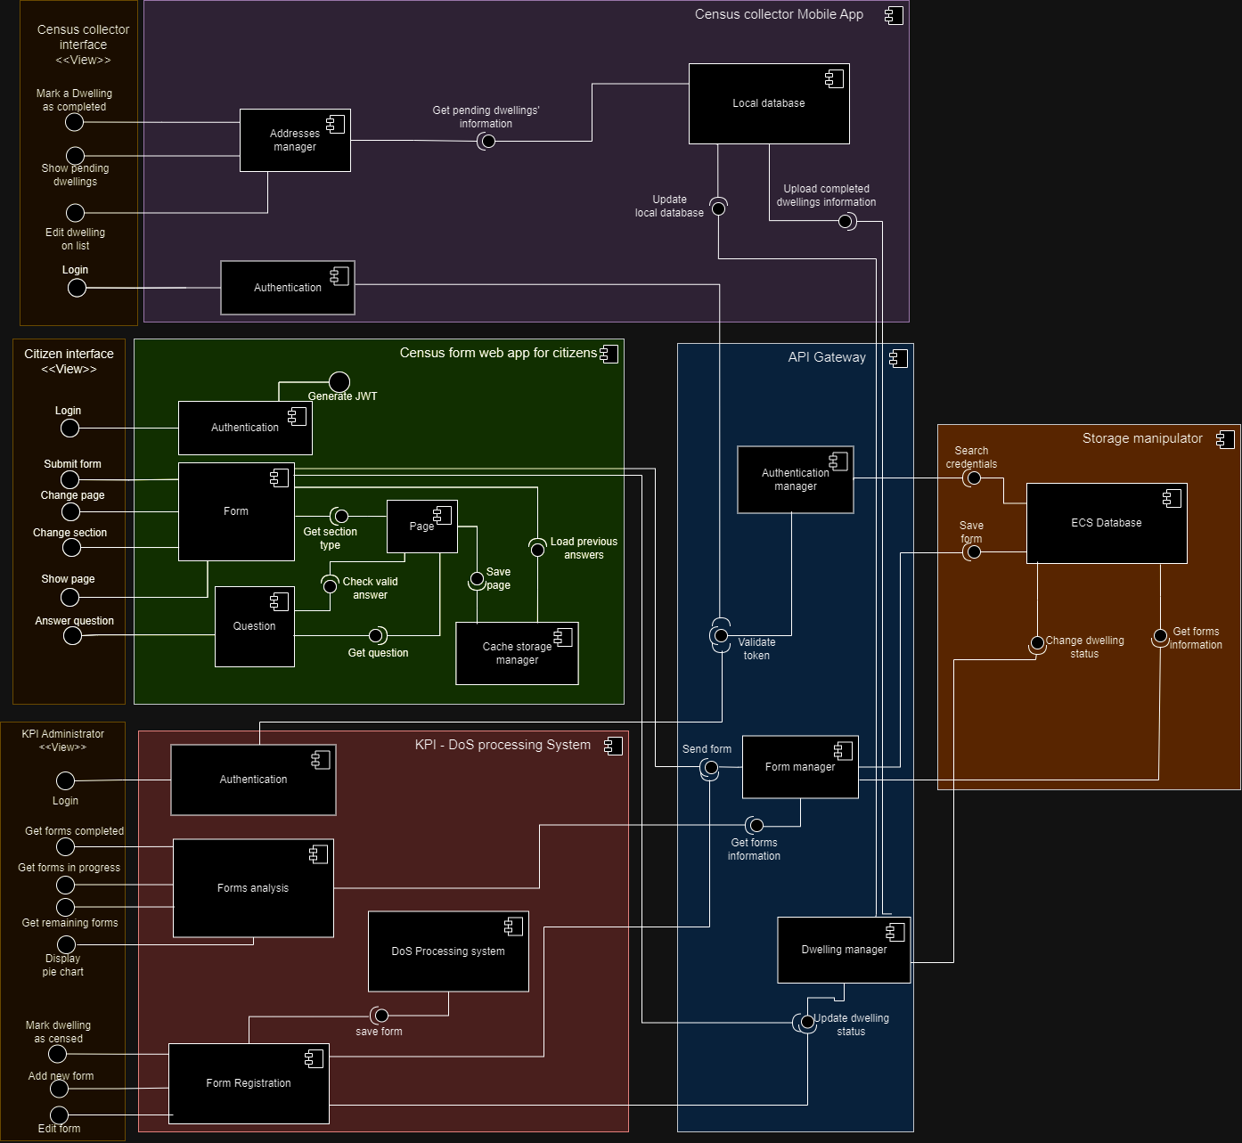

[**https://drive.google.com/file/d/1By3DchYKLEmydrAFHK6T1eyjR1e5f27w/view?usp=sharing**](https://drive.google.com/file/d/1By3DchYKLEmydrAFHK6T1eyjR1e5f27w/view?usp=sharing)

**2.1.4 Deployment diagram**

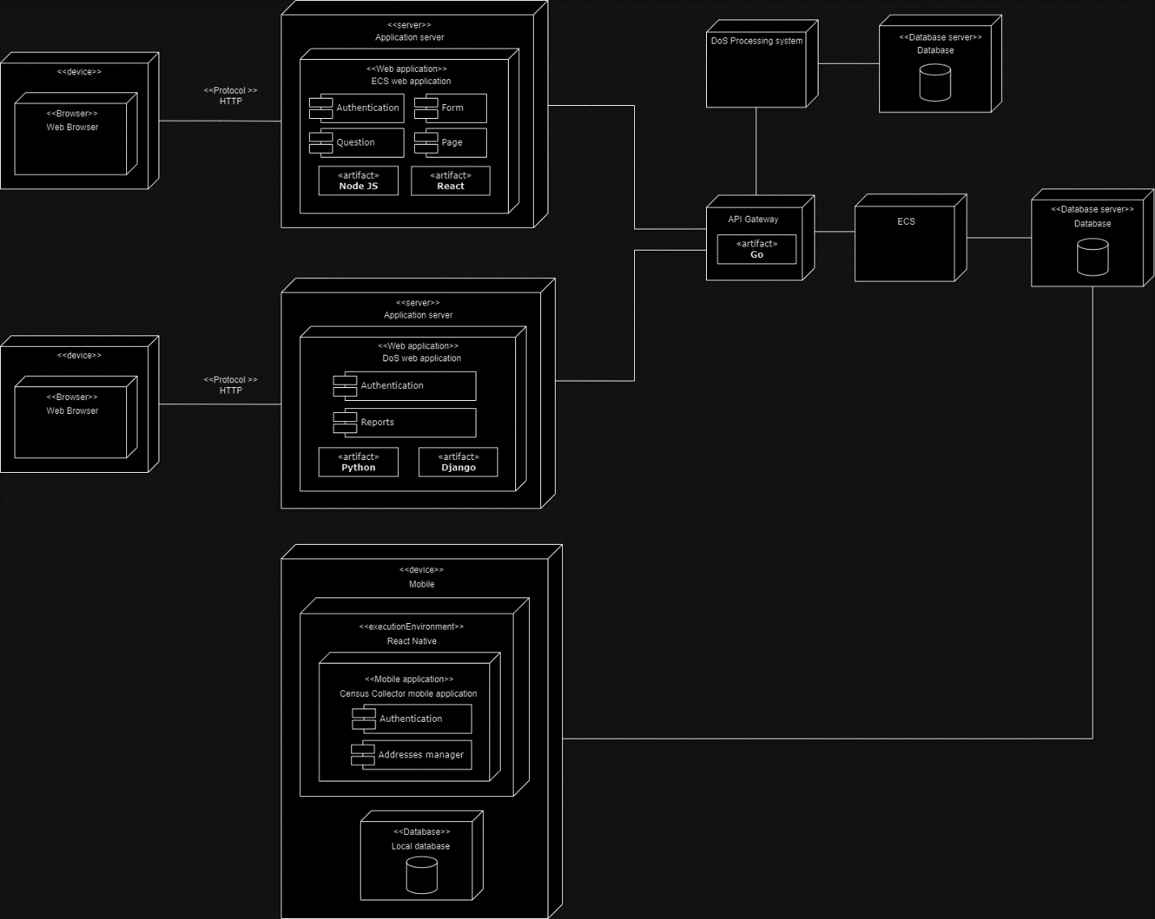

[**https://drive.google.com/file/d/19mnVV9A2AtY5r4_28TJp-8GMrGVhP7Z5/view?usp=sharing**](https://drive.google.com/file/d/19mnVV9A2AtY5r4_28TJp-8GMrGVhP7Z5/view?usp=sharing)

## 2.2 System Actors

### 2.2.1 User Roles and Responsibilities / Authority Requirements

|  |  |  |  |  |
| --- | --- | --- | --- | --- |
| **User/Role** | **Example** | **Frequency of Use** | **Security/Access, Features Used** | **Additional Notes** |
| Citizen of Bolumbia | *Danny Salcedo Saldaña* | Very frequent | Each household is granted a unique CFN, which they use to fill and send an electronic form | Population is 23 million |
| Census collector | *Pablo Maya Villegas* | Frequent | They get granted the data of the households that have already completed the census | There are 27.000, each assigned a district/sector. |
| Department of statistics (DoS) | An external group | Occasional | Has the authority to analyze the data and gives access to the addresses database | None |
| DoS Electronic census processing system | A server | Very Frequent | Has the authority to send and store data to whom its choses, it displays real time statistics of the processed data | None |
| Support staff | *Hobarlan Uparela Arroyo* | Occasional | Has the direct access to the system, and has the power to modify the inner workings, however, they don’t have access to the data | None |
| Help desk | *Mateo Muñoz Cadavid* | Rare | Is given the application usage information to be able to assist users | None |

## 2.3 Logical diagrams

### 2.3.1 Logical Location Diagram

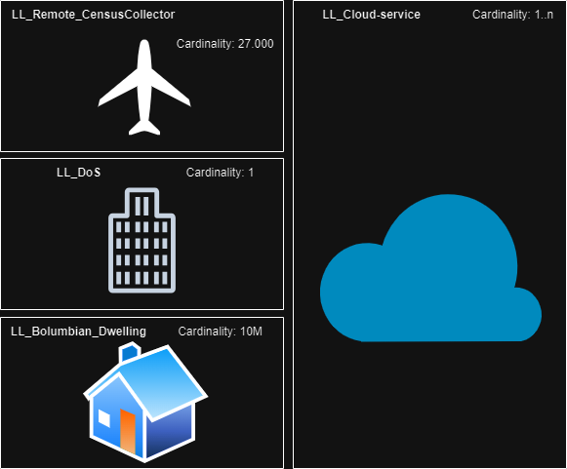

<https://drive.google.com/file/d/1Q9TCm-o3oLcLKKp8ekUOZygaJ5V50gmY/view?usp=sharing>

### 2.3.2 Logical Node Diagram

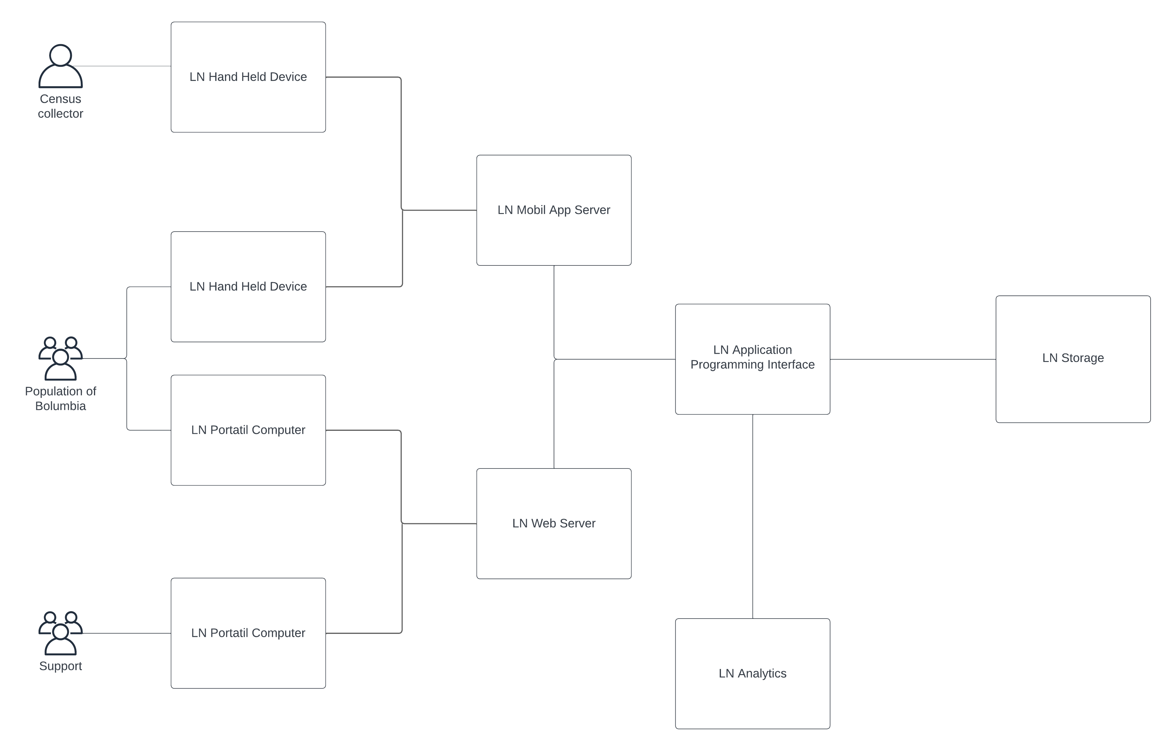

<https://lucid.app/lucidchart/9bf13e2e-6dd6-47c3-bd14-23768082fa17/edit?viewport_loc=-1497%2C-689%2C3196%2C1477%2C0_0&invitationId=inv_2b0e92f5-26e1-4485-804c-c8ad3bce52a3>

### 2.3.2 Logical Operation Mode

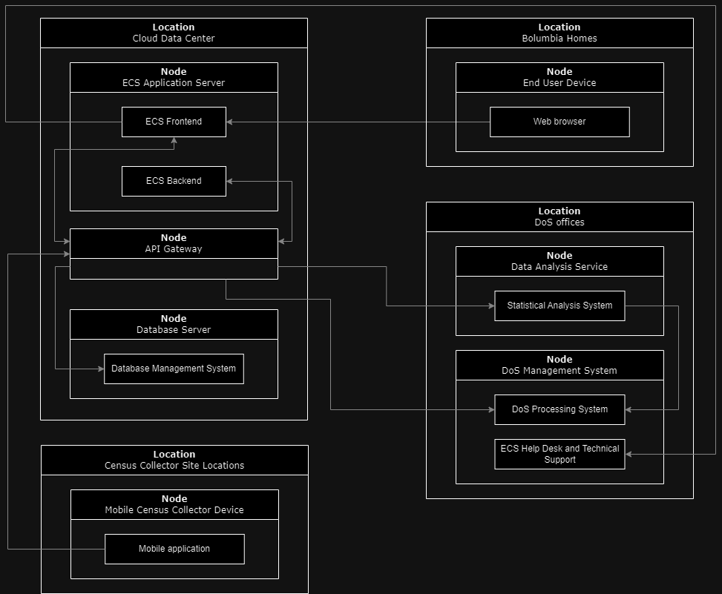

<https://drive.google.com/file/d/1myC2yfvQIPE7e4Wba9e3rAdf00Wa35nU/view?usp=sharing>

### 2.3.3 Physical Operational Model

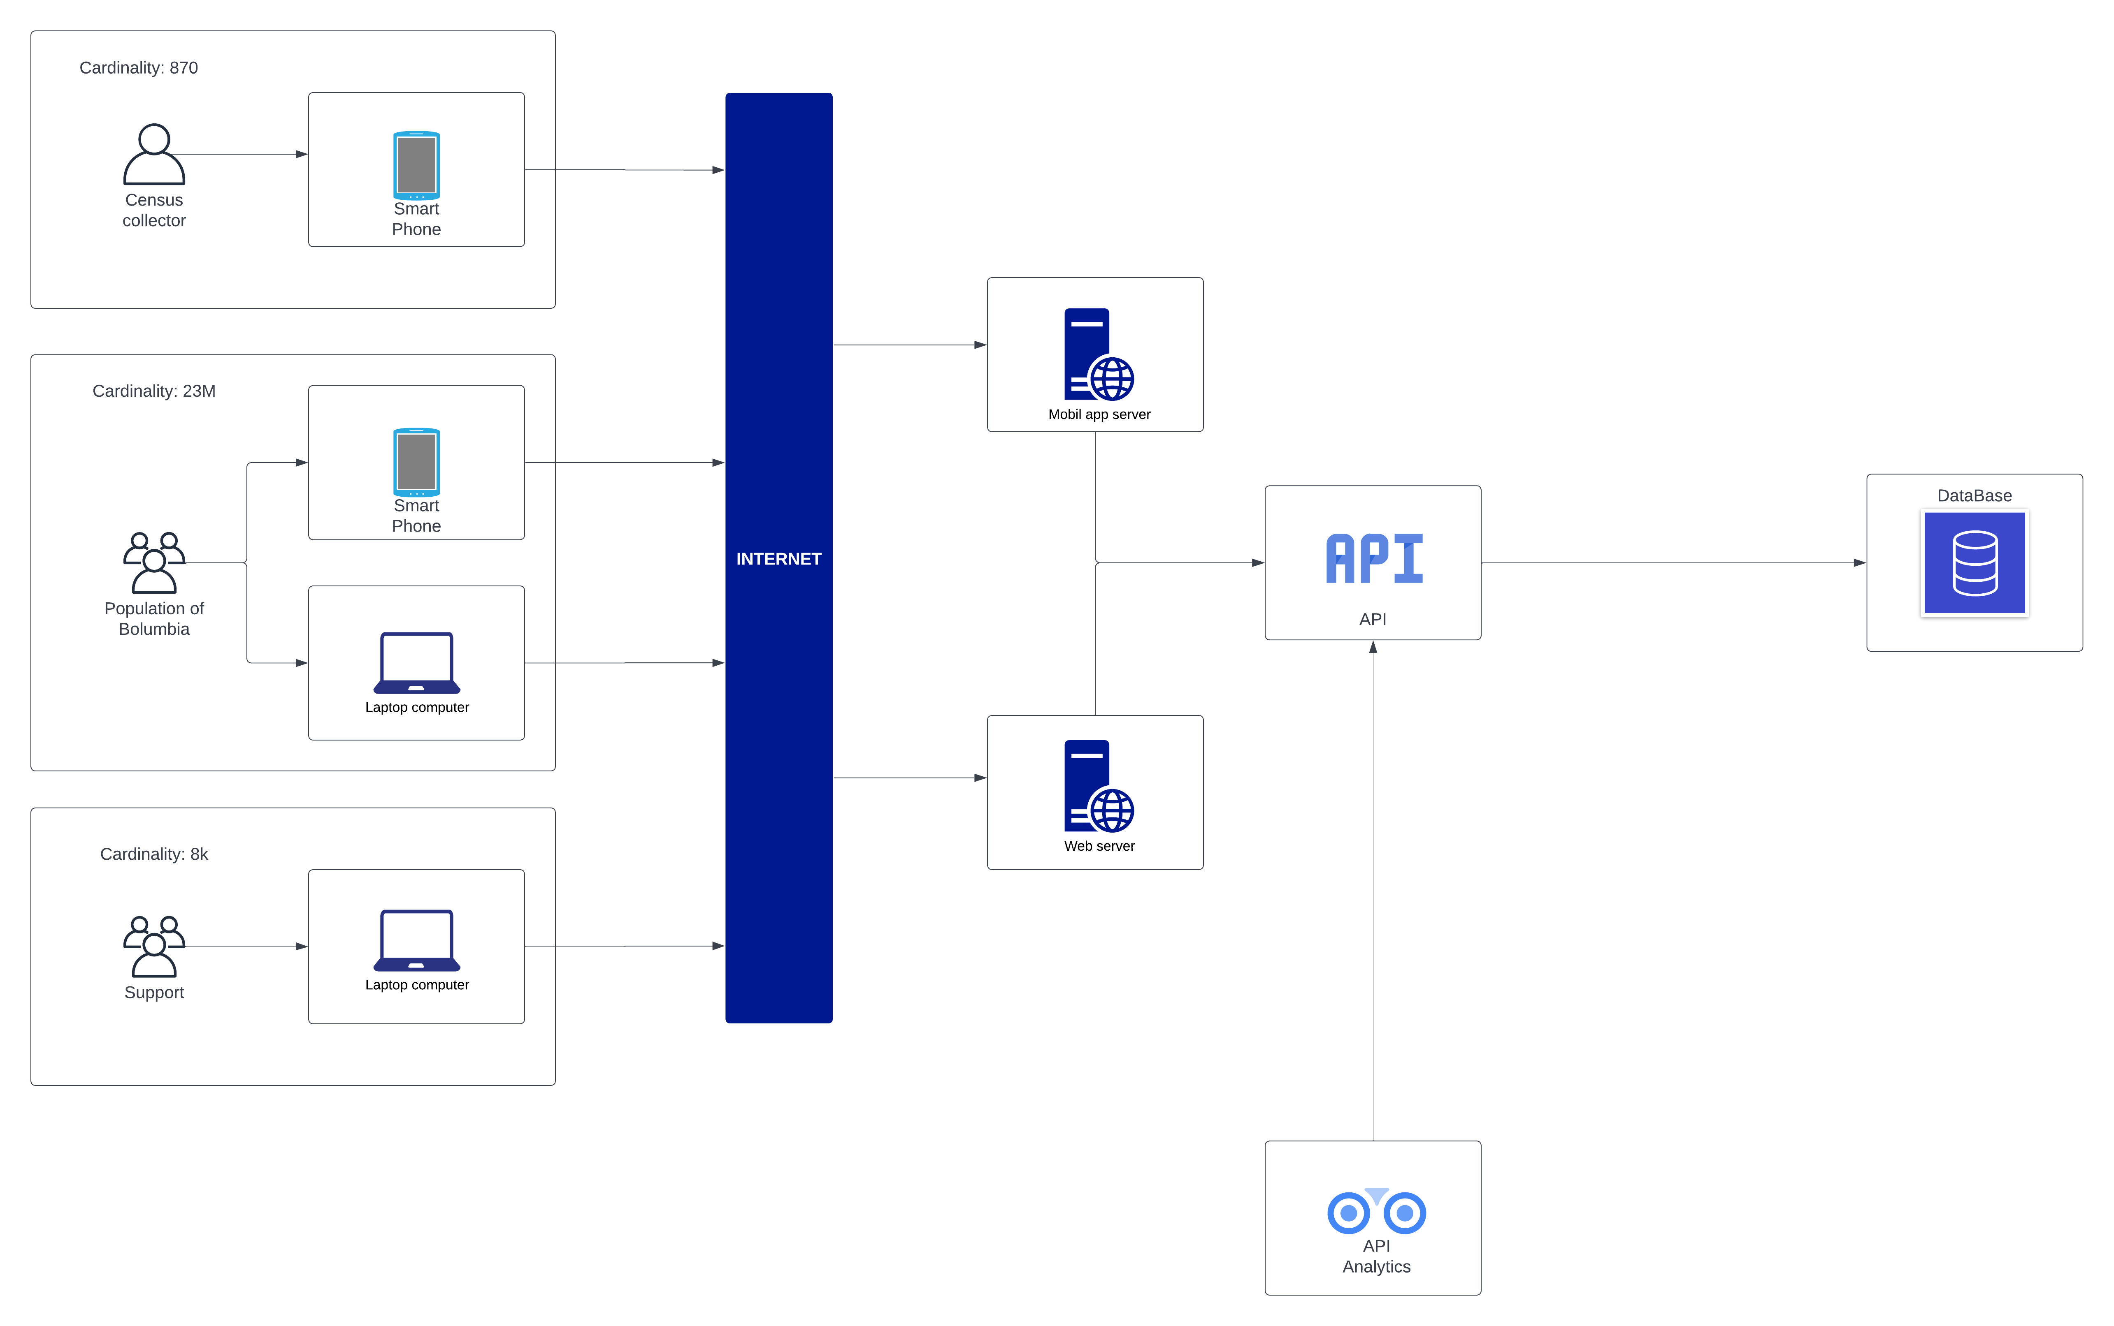

<https://lucid.app/lucidchart/74d8d07c-8447-4a52-bf87-531855f2d71d/edit?viewport_loc=-3117%2C-1144%2C7944%2C3454%2C0_0&invitationId=inv_97b3b812-8fbe-4b61-b097-2df5aea17b6e>

# Functional Specifications

### 3.1.1 Purpose/ Description

This section details the essential functional requirements for the development of the Electronic Census System (ECS) of the Department of Statistics (DoS) of the Republic of Bolumbia. These requirements, derived from the previously identified business needs, establish the necessary guidelines to ensure that the ECS achieves its objectives effectively, meeting regulatory and user experience expectations. Additionally, detailed use cases are included to serve as a comprehensive guide for the development of the system.

### 3.1.2 Use cases and their respective sequence diagram

|  |  |  |
| --- | --- | --- |
| **Level Types on Use Case** | | |
| **WHITE** | | Enterprise and highest level. |
| **KITE** | | This use case may be at the business unit or department level and is a summary of goals. |
| **BLUE** | | It is usually created for user goals. |
| **INDIGO** | | It shows lots of detail, often at a functional or sub-functional level. |
| **BLACK** | | Are the most detailed use cases, at a subfunction level. |
|  | | |
| **UC-1** | Remove addresses from collection lists. | |
| **CHARACTERISTIC INFORMATION** | | |
| **Goal in Context** | The ECS system should remove the addresses from Census Collectors collection lists’ when any user completes the Census return using the ECS web app. This indicates that the person completed the form through ECS web app and doesn’t need a collector to complete the process. | |
| **Scope** | This use case covers the entire process from completing the Census form to sending the Census Collector an update to their mobile app enabling them to mark the address as “completed” from Collection Lists. | |
| **Level** | Indigo. | |
| **Preconditions** | * The user must have completed his own form through the ECS web app. * The ECS should have transferred the Census Form Number and address detail of that user to the Electronic Census Processing System. | |
| **Success End Condition** | The appropriate Census Collector receives an updated database to their mobile app with the addresses of the people who already completed the Census Form via internet marked as “completed” and update the Collector’s list. | |
| **Failed End Condition** | The Census Collector doesn’t receive the update due to bad connection and will visit those addresses looking for Census physical forms. | |
| **Primary Actor** | Census Collector. | |
| **Trigger** | There is an update on the status of a Dwelling. | |
| **MAIN SUCCESS SCENARIO** | | |
| 1. The ECS system will send an update to the appropriate Census Collector mobile app local database. 2. Once the Census Collector has received the update they will be informed of the changes and their Collector list will have that address removed. 3. The DoS Processing System should also be informed of this update for the real-time analytics. | | |
| **EXTENSIONS** | | |
| 1. If the Census collector checks an address and receives the physical form, they can manually remove that address from the collector list in their mobile app. 2. This update is sent to the ECS system, and it updates the data. 3. The DoS Processing System receives an update. | | |
| **SUB-VARIATIONS** | | |
| * If the Census collector mobile app appears offline or the connection is failed, the system will try again in 5 minutes, or the mobile app will request an update once it resumes online. * If the household completes their paper form and submits it to the mail, the DoS should inform the ECS of the acknowledgment of this form and the ECS updates the Census Collector list. | | |
| **RELATED INFORMATION** | | |
| **Priority** | Medium. | |
| **Performance Target** | The system should be able to send the database update to the Census Collector mobile app in no more than 5 seconds after receiving the user information. | |
| **Frequency** | Frequent. | |
| **Superordinate Use Case** | UC-2 | |
| **Subordinate Use Cases** | None | |
| **Secondary Actors** | Census collector mobile app, ECS and DoS Processing System. | |
| **Channels to Secondary Actors** | Communications via internet HTTP requests. | |
| **OPEN ISSUES** | | |
| * How will be managed the Census forms sent by physical mail? * Will the address details of those Census forms be sent to the Census Collector to prevent his visit? | | |
| **SCHEDULE** | | |
| **Due Date** | Census night. | |

<https://drive.google.com/file/d/1F5YYef7zOO0q10rzL1S9zLXULskrc0X5/view?usp=sharing>

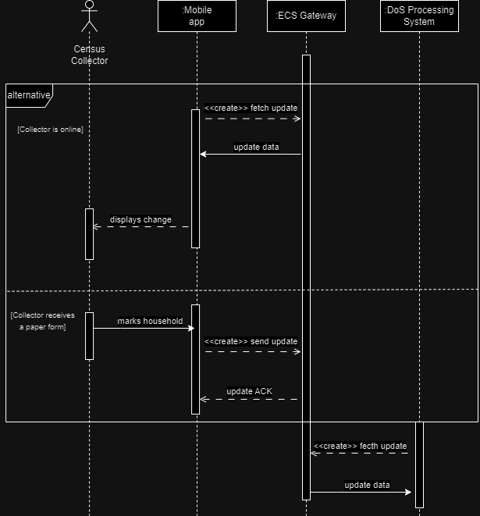

|  |  |
| --- | --- |
| **UC-2** | Transfer of ECS Returns to Electronic Census Processing System |
| **CHARACTERISTIC INFORMATION** | |
| **Goal in Context** | Transmit completed Census returns from respondents using the Electronic Census System (ECS) to Electronic Census Processing. |
| **Scope** | This use case encompasses the data transfer process from the ECS to the Electronic Census Processing System. |
| **Level** | Kite |
| **Preconditions** | Respondents have successfully submitted their Census responses using the ECS system. |
| **Success End Condition** | Completed Census data is successfully transferred from the ECS system to the Electronic Census Processing System for further aggregation and analysis. |
| **Failed End Condition** | Completed Census data is successfully transferred from the ECS system to the Electronic Census Processing System for further aggregation and analysis. |
| **Primary Actor** | The Electronic Census System (ECS). |
| **Trigger** | A respondent successfully completes their Census response using the ECS. |
| **MAIN SUCCESS SCENARIO** | |
| 1. A respondent completes their Census response using the ECS. 2. The ECS system validates the submitted data. 3. After successful validation, the ECS initiates a secure data transfer to the Electronic Census Processing System. 4. The electronic Census Processing System receives the data and checks its integrity. 5. If the check is successful, the Electronic Census Processing System acknowledges the receipt to the ECS. 6. The ECPS processes the data and shows real time analytics and statistics. | |
| **EXTENSIONS** | |
| 2a. Incomplete or Invalid data 4a. Data not received 4b. Check failed | |
| **SUB-VARIATIONS** | |
| 1. Respondents may send Census response using different methods as mail or Census collector | |
| **RELATED INFORMATION** | |
| **Priority** | High |
| **Performance Target** | ECS returns should be transferred within minutes of successful submission. |
| **Frequency** | Frequent. |
| **Superordinate Use Case** | None |
| **Subordinate Use Cases** | UC-1 (Remove addresses from collection lists) |
| **Secondary Actors** |  |
| **Channels to Secondary Actors** | None |
| **OPEN ISSUES** | |
|  | |
| **SCHEDULE** | |
| **Due Date** | Ongoing |

<https://drive.google.com/file/d/1_xILsCzU_O6A1aMYHY3-62sZMkbxRpVF/view?usp=sharing>

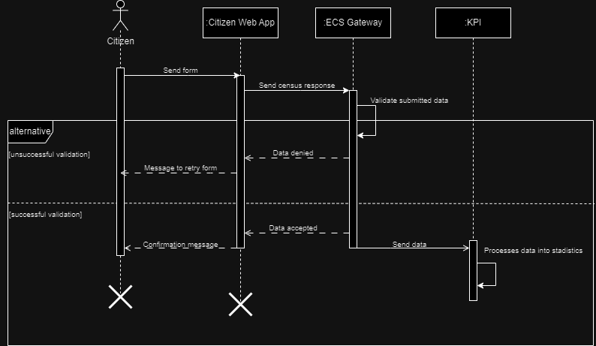

|  |  |
| --- | --- |
| **UC-3** | Citizen sends electronic census form |
| **CHARACTERISTIC INFORMATION** | |
| **Goal in Context** | The goal of this use case is to successfully receive the contents of an electronic census form sent by a Bolumbian citizen |
| **Scope** | This use case covers the prosses from receiving the CFN to successfully submitting the form |
| **Level** | Blue |
| **Preconditions** | The citizen’s CFN has been successfully delivered.  It’s a private household. |
| **Success End Condition** | The form is received by the ECS system |
| **Failed End Condition** | The user can’t complete the digital census and requires assistance |
| **Primary Actor** | Boluvian citizen |
| **Trigger** | The census enumeration period |
| **MAIN SUCCESS SCENARIO** | |
| 1. The household head citizen has in their possession their CFN. 2. The citizen decides to start the electronic census form. 3. The citizen submits their CFN in the address section, and after confirmation from the server continues the process. 4. The citizen fills in the person, dwelling and feedback sections, then clicks submit to send the form. 5. All required fields are filled, and the form is sent. 6. The form arrives to the ECS system | |
| **EXTENSIONS** | |
| 1a. The citizen doesn’t have or lost their CFN and needs to contact the Census help desk or fill in the paper form.  3a. The CFN is incorrect, the citizen needs to contact the Census help desk or fill in the paper form.  5a. The citizen misses a required field, the form marks where is the missing field.  5b. The form isn’t correctly received, and the citizen isn’t informed, in this case the Census collector eventually will check the house manually because the address hasn’t been removed.  6a. The form doesn’t arrive, the app tries again and if it keeps failing it informs the citizen the possible connection error. | |
| **SUB-VARIATIONS** | |
| The citizen may discard the CFN and choose to do the paper form instead. | |
| **RELATED INFORMATION** | |
| **Priority** | High |
| **Performance Target** | The system should have 99% capacity and uptime on census night. |
| **Frequency** | Thousands of forms are sent daily, and on census night millions might |
| **Superordinate Use Case** | None |
| **Subordinate Use Cases** | UC-1 |
| **Secondary Actors** | Census help desk, Census collector |
| **Channels to Secondary Actors** | Phone, mail, chat, SMS. |
| **OPEN ISSUES** | |
| The household is empty, and it didn’t fill in the physical or electronic census form.  The household might not have any electronic devices to fill the electronic form. | |
| **SCHEDULE** | |
| **Due Date** | Census night |

<https://drive.google.com/file/d/1fpsTxPW3-1a6Q0_YDmeKcRqutThxUc75/view?usp=sharing>

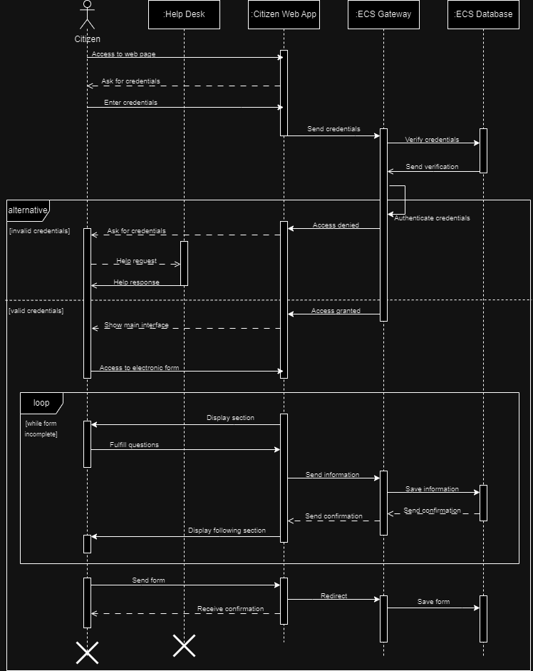

|  |  |
| --- | --- |
| **UC-4** | Reporting errors in the ECS |
| **CHARACTERISTIC INFORMATION** | |
| **Goal in Context** | Allow users to report any errors, technical issues, or difficulties they encounter while using the ECS |
| **Scope** | This use case encompasses from the moment the user identifies an error or issue to the recording and notification of the problem to the technical support team. |
| **Level** | Blue |
| **Preconditions** | * The user has encountered an error or issue while using the ECS. * The user has access to the system´s error reporting functionality. |
| **Success End Condition** | The user has successfully recorded the error or issue in the system and has received confirmation that the report has been sent to the technical support team. |
| **Failed End Condition** | The user was unable to record the error or issue due to technical or connectivity problems. |
| **Primary Actor** | Citizen |
| **Trigger** | The user encounters an error |
| **MAIN SUCCESS SCENARIO** | |
| * The user accesses the ECS´s error reporting functionality. * The system presents a form or interface for the user to describe the encountered error or issue. * The user provides details about the error, including a description of the problem and any relevant information. * The system validates and records the user´s error report. * The system displays confirmation that the error report has been successfully recorded. * The user receives a confirmation message and completes the process. | |
| **EXTENSIONS** | |
|  | |
| **SUB-VARIATIONS** | |
|  | |
| **RELATED INFORMATION** | |
| **Priority** | Medium |
| **Performance Target** | The error registration process should not take more than 5 minutes to complete. |
| **Frequency** | Anytime a user encounters an error or issue |
| **Superordinate Use Case** | None |
| **Subordinate Use Cases** | None |
| **Secondary Actors** | Technical support team |
| **Channels to Secondary Actors** | Notification via email to the technical support team |
| **OPEN ISSUES** | |
|  | |
| **SCHEDULE** | |
| **Due Date** |  |

<https://drive.google.com/file/d/1tycLdPsYfXgD9H7PBA_ZJ2P8quHJYO0D/view?usp=sharing>

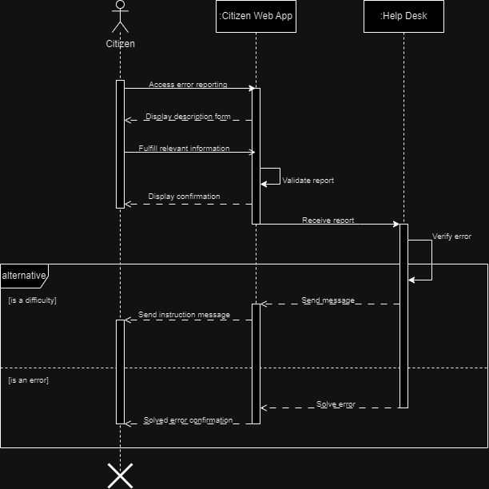

### 3.1.4 Functional Requirements

|  |  |  |
| --- | --- | --- |
| **Spec ID** | **Specification Description** | **Business Rules/ Data Dependency** |
| FR01 | The system must capture Census information electronically through the internet using a desktop or mobile device. | All the fields in the form must be completed and valid before sending all the information, also, all CFN must be unique for each Census form. |
| FR02 | The system must allow the registered users to login using their access credentials (Electronic Census Number and Census Form Number). | All the people must receive a paper Census form with both data (CFN and Electronic Census Number), which are unique for each form. |
| FR03 | The system should ensure that each submitted Census response is timestamped to record the date and time of submission. | The system should automatically adjust to the user´s local time zone to ensure the accuracy of the timestamp. |
| FR04 | The ECS system must catch the CFN and address details of respondents who complete their Census return, to send it to the Census Collector via the mobile app connection. | The form must have been sent and processed by the Electronic Census Processing system of the DoS, because this is the validation to send this information to the Census Collector and indicate that he doesn’t have to collect anything at the mentioned address. |
| FR05 | The application must provide the help desk with sufficient information and usage explanations to enable them to assist and guide users effectively in utilizing the platform. | Help desk representatives must have access to an up-to-date knowledge base that includes clear and detailed instructions on how to use various functionalities of the platform. The information should be presented in a searchable and understandable format, enabling them to provide efficient user assistance. |
| FR06 | Respondents should answer Census questions based on the situation within their dwelling on Census night (the first Tuesday of August, 3 years from now). | Census responses submitted must reflect the dwelling's status exclusively on Census night.  The users will not be allowed to send answers after Census night. |
| FR07 | The ECS platform should seamlessly transmit newly submitted Census returns to the DoS Electronic Census Processing system, which subsequently transfers data to the DoS Census database. | Data transfer formats and protocols must be standardized and consistent across systems. |
| FR08 | The ECS system must establish and maintain a daily bidirectional communication with the Department of Statistics (DoS) for the exchange of crucial information and reports necessary for the effective functioning of the system and census operations. | Shared data must include daily reports, census response details, status updates, and other relevant data.  Data formats and exchange schedules must be predefined and agreed upon between DoS and the ECS development team.  The exchange process should be automated and scheduled to run daily at specific times. |
| FR09 | The ECS system must transfer the Census Form Number (CFN) and address details of respondents who complete their Census return using ECS to the DoS Electronic Census Processing system. | Transferring respondent address details and Census Form Numbers (CFNs) from completed ECS Census returns to the DoS Electronic Census Processing system, excluding form content, requires robust data validation for accuracy prior to transfer. CFNs must match valid, issued Census Forms, while address data integrity is vital during ECS-DoS transfers. |
| FR10 | The Census Collector mobile app has an interface that displays all addresses and their status. | This app should work offline and there should be authentication in case of robbery or loss of the electronic device. |
| FR11 | The Census Collector mobile app has an option to mark an address that has already given their paper form to the Census Collector as completed. | This data change should also be communicated to the ECS and the DoS processing system. |
| FR12 | The Census Collector can access their mobile app on their personal device. | The app should work on Android and iPhone devices and be provided to the Collectors prior to their workday. |
| FR13 | The Census Collector must be given a username and a password to access their app. | The API should use this data to confirm the identity and zone of the Collector and should ask frequently a token refresh from the mobile app. |
| FR14 | The DoS processing system must fetch an update to have the most recent data every hour. | This data is used to create real-time analytics that display the number of current forms completed, in progress and not started. |

# Other System Requirements/ Non-Functional Requirements

|  |  |
| --- | --- |
| **Spec ID** | **Specification Description** |
| NFR01 | The system must comply with the obligation of Bolumbia’s Department of Statistics under the Electronic Transactions Act 2009. (Security) |
| NFR02 | The system responds to public requests for increased flexibility in methods of completing Census materials. (Manageability) |
| NFR03 | The ECS maintains the privacy and perception of privacy, in that DoS holds a unique security access key to the managed data, and only staff employed under the Statistics Act can access the raw respondent data. (Security, Identity and Authority) |
| NFR04 | The support services for the application, infrastructure and Census should be provided. (Usability, Availability, Manageability and Serviceability) |
| NFR05 | The solution implementation should include testing and production deployment. (Testability and Realizability) |
| NFR06 | The system must allow users to complete the Census response at any time during the enumeration period. (Availability) |
| NFR07 | The system must use a cloud-based environment to host the services. (Scalability and Performance) |
| NFR08 | The system's ability to handle an increase in the number of users and data without compromising its performance. (Scalability) |
| NFR09 | The ECS system should have high availability, minimizing downtime during the Census enumeration period, especially on Census Night. (Reliability, Availability) |
| NFR10 | The application must inform the user of the possible channels of support to communicate with the Census help desk in case they need help. There should be multiple ways to contact this support, phone, chat, mail, and SMS. (Serviceability) |
| NFR11 | The system should have 99% capacity and uptime on census night. (Performance, Availability, Scalability, Serviceability) |
| NFR12 | The web app should save the current state of the form when the page changes. (Integrity) |
| NFR13 | When there’s no connection between the ECS and the Census collector mobile app, the Mobile App should try to send the update in the next second. (Reliability, Integrity) |
| NFR14 | All data transfers should be in a consistent JSON format and there should be acknowledgements for every data transfer. (Throughput, Integrity) |
| NFR15 | The system should be able to tolerate at least 10.000 petitions at a time by automatically scaling via Kubernetes usage on Census night. (Scalability, Plannability) |

|  |  |  |  |  |  |  |  |  |  |  |  |  |  |  |  |
| --- | --- | --- | --- | --- | --- | --- | --- | --- | --- | --- | --- | --- | --- | --- | --- |
| **NFR** | **01** | **02** | **03** | **04** | **05** | **06** | **07** | **08** | **09** | **10** | **11** | **12** | **13** | **14** | **15** |
| Performance |  |  |  |  |  |  | **X** |  |  |  | **X** |  |  |  |  |
| Reliability |  |  |  |  |  |  |  |  | **X** |  |  |  | **X** |  |  |
| Availability |  |  |  | **X** |  | **X** |  |  | **X** |  | **X** |  |  |  |  |
| Throughput |  |  |  |  |  |  |  |  |  |  |  |  |  | **X** |  |
| Manageability |  | **X** |  | **X** |  |  |  |  |  |  |  |  |  |  |  |
| Security | **X** |  | **X** |  |  |  |  |  |  |  |  |  |  |  |  |
| Identity |  |  | **X** |  |  |  |  |  |  |  |  |  |  |  |  |
| Authority |  |  | **X** |  |  |  |  |  |  |  |  |  |  |  |  |
| Confidentiality |  |  |  |  |  |  |  |  |  |  |  |  |  |  |  |
| Integrity |  |  |  |  |  |  |  |  |  |  |  | **X** | **X** | **X** |  |
| Auditability |  |  |  |  |  |  |  |  |  |  |  |  |  |  |  |
| Testability |  |  |  |  | **X** |  |  |  |  |  |  |  |  |  |  |
| Serviceability |  |  |  | **X** |  |  |  |  |  | **X** | **X** |  |  |  |  |
| Plannability |  |  |  |  |  |  |  |  |  |  |  |  |  |  | **X** |
| Realizability |  |  |  |  | **X** |  |  |  |  |  |  |  |  |  |  |
| Scalability |  |  |  |  |  |  | **X** | **X** |  |  | **X** |  |  |  | **X** |

# References

<https://www.w3computing.com/systemsanalysis/use-case-levels/>

<https://www.ibm.com/docs/en/atlas-policy-suite/6.0.3?topic=overview-architectural>

<https://www.unified-am.com/UAM/index.htm#UAM/guidances/supportingmaterials/uam_welcome_5C65E9E8.html>

<https://www.unified-am.com/UAM/index.htm#UAM/customcategories/uam_templates_1C0B7323.html>

<https://www.unified-am.com/UAM/index.htm#UAM/guidances/templates/uam_architectural_decision_A2190D71.html>

<https://www.unified-am.com/UAM/index.htm#UAM/guidances/templates/uam_context-objectives_9388FED6.html>

<https://www.unified-am.com/UAM/index.htm#UAM/guidances/templates/uam_technical_perspective_doc_DC03D51C.html>

<https://www.ibm.com/docs/en/rational-soft-arch/9.5?topic=abstraction-modeling-operational-logical-layout-applications>